Curriculum Vitae
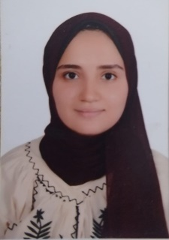
Contact data:
- Name: Yousra Adel Abdelaziz
- Address: Assuit _ Egypt.
- Mobile number: 01014943290
- E-mail: yousraelsagheir@gmail.com
yousraadel@pharm.aun.edu.eg
Personal information:
- Nationality: Egyptian.
- Date of birth: 8/8/1996
- Gender: Female
Education:
Bachelor degree in Faculty of Pharmacy, Assuit University May 2019
Graduation Grade: excellent with honour
Experience:
- At 2019: trained at Dr hamdimisk pharmacy
- At 2020: worked at Dr fatenpharmcy
- At 2014: attended and trained an ICDL course .
- At 2016: attended a course at faculty of pharmacy about :
- Commercial cosmetology
- Refrigerator drugs
- Therapeutic nutrition
- Drug food interaction
Personal skills:
- Active, Self-motivated and Dynamic.
- Excellent communication skills.
- Ability to work individually and as co-operative team member.
- Ability to learn new tasks quickly.
- Ability to work under pressure
Language skills:
- Good command of English language (spoken - written).
- Native speaker of Arabic as the mother language.
Computer skills:
- Good in the use of Microsoft Office software
- (Windows,Word ,Power point,Internet and Excel).
- Very Good user of the Internet.
- Sending and receiving e-mails by Outlook Express.
Interests:
- Reading and Surfing the net.
- Traveling and know new cultures.
- Participating in charity and voluntary.

